**CXF+ Web Service(SOAP) + Apache Camel Example**

Step 1:

Download apache cxf 2.4.2 bin from below link

<https://archive.apache.org/dist/cxf/2.4.2/apache-cxf-2.4.2.zip>

Step 2:

Unzip it to local drive.

Step 3:

Start Eclipse

Go to Windows🡪Preferences🡪Web Services🡪CXF 2.x Preferences

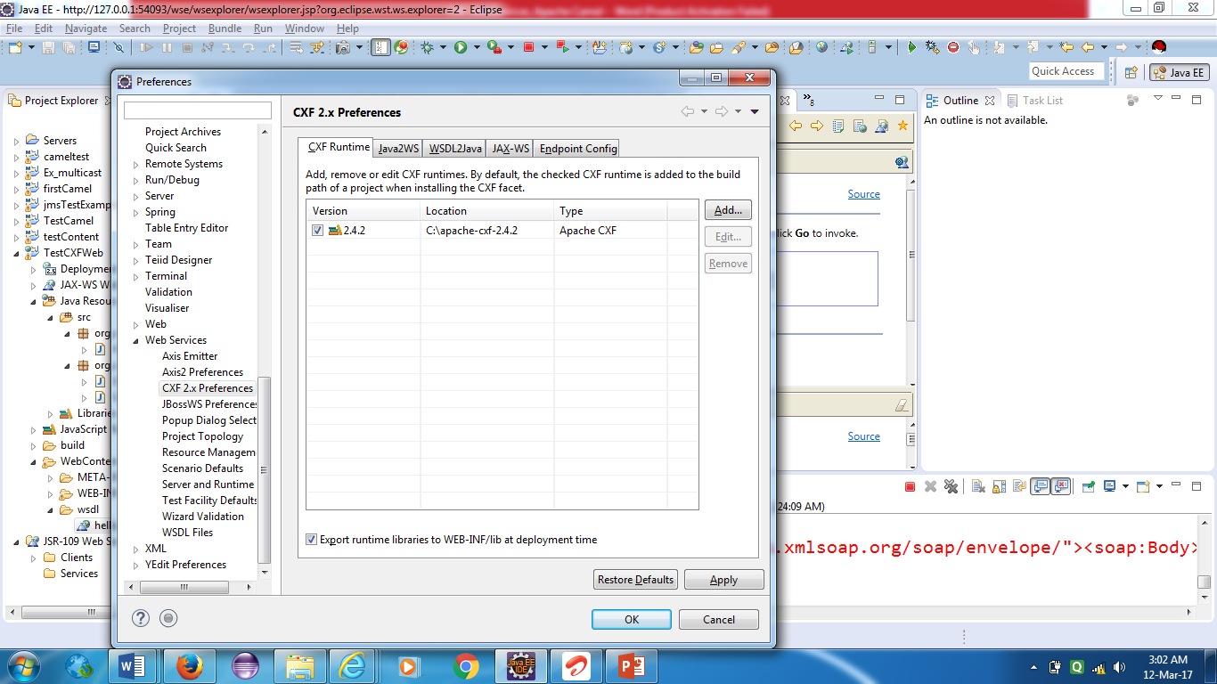

Click on add button to add the home location of cxf 2.4.2

Once it is added, click on apply🡪OK.

Step 4:

Create Dynamic Web Project

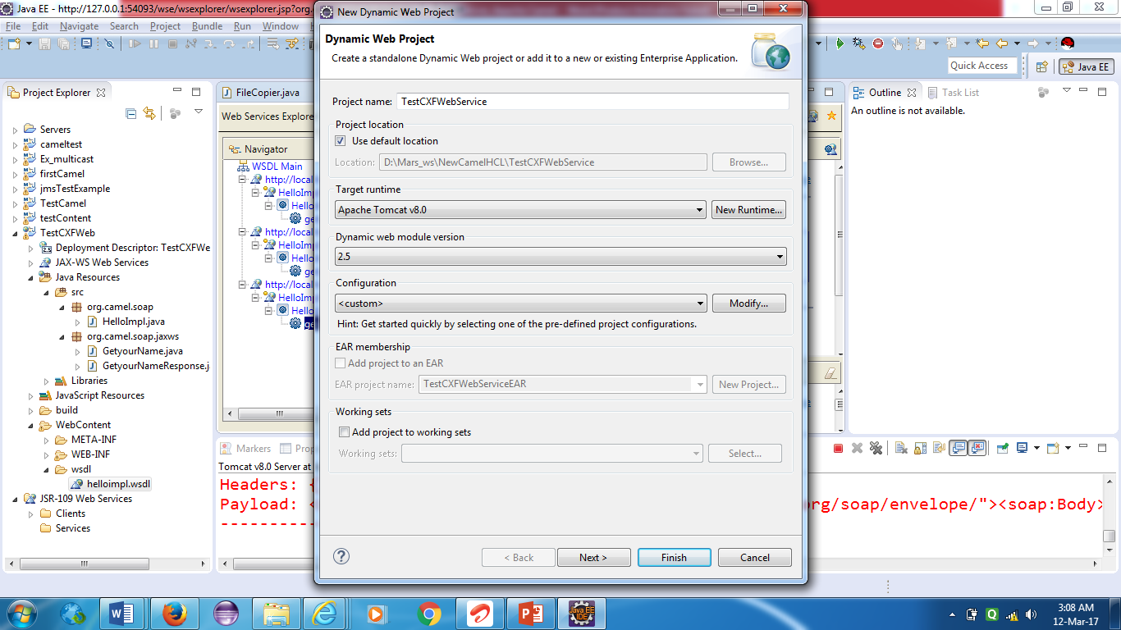

Click on modify button

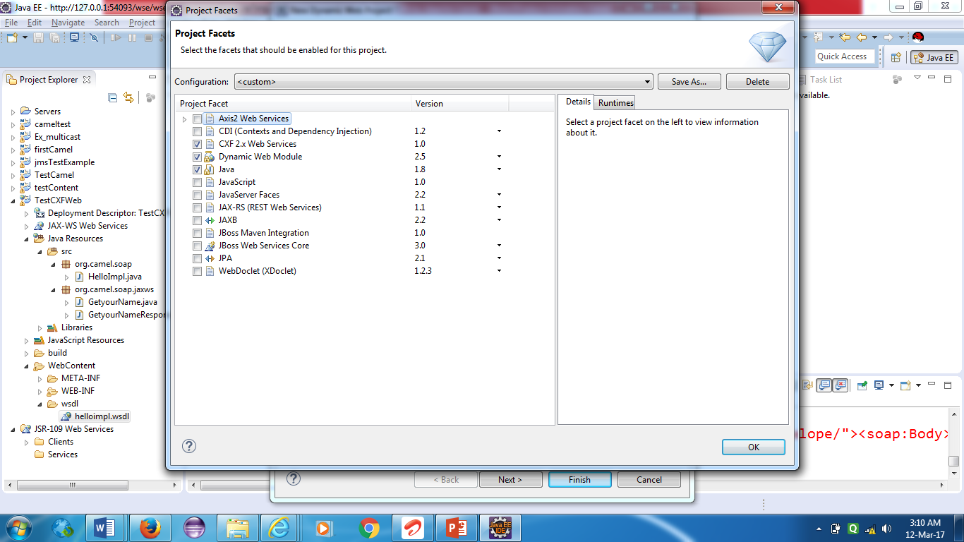

Select the CXF 2.x Web Services then click OK.

Step 5:

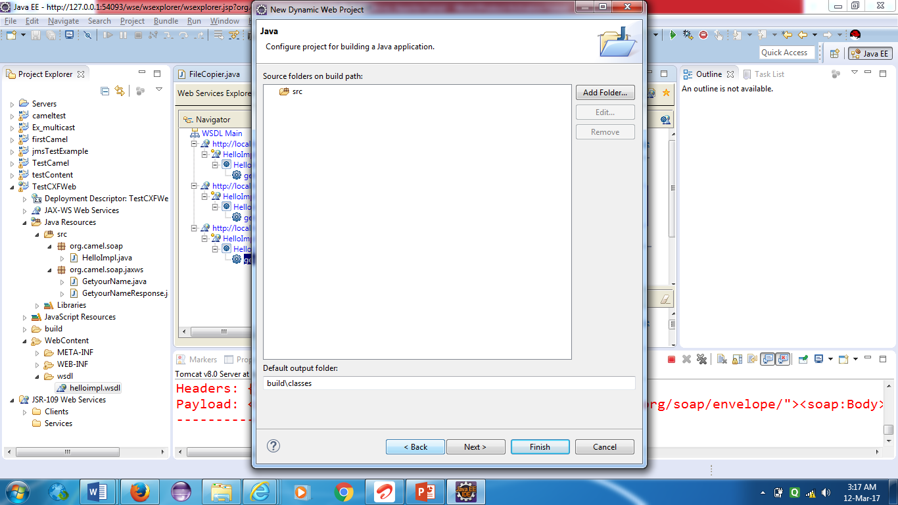

Step 6:

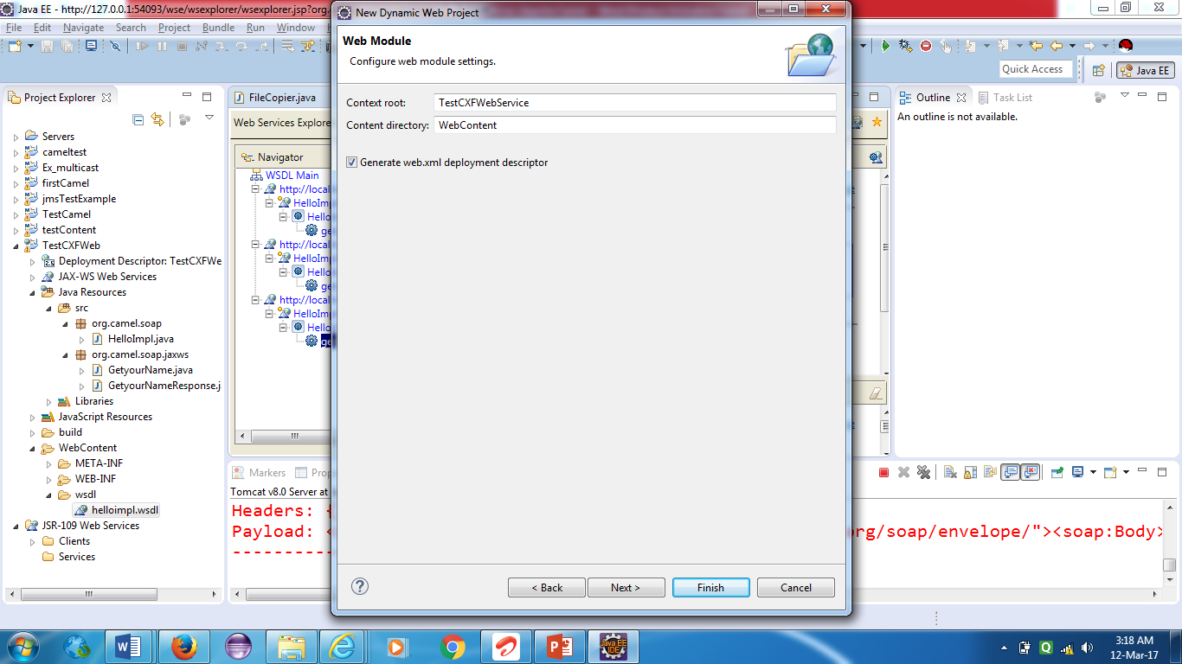

Step 7:

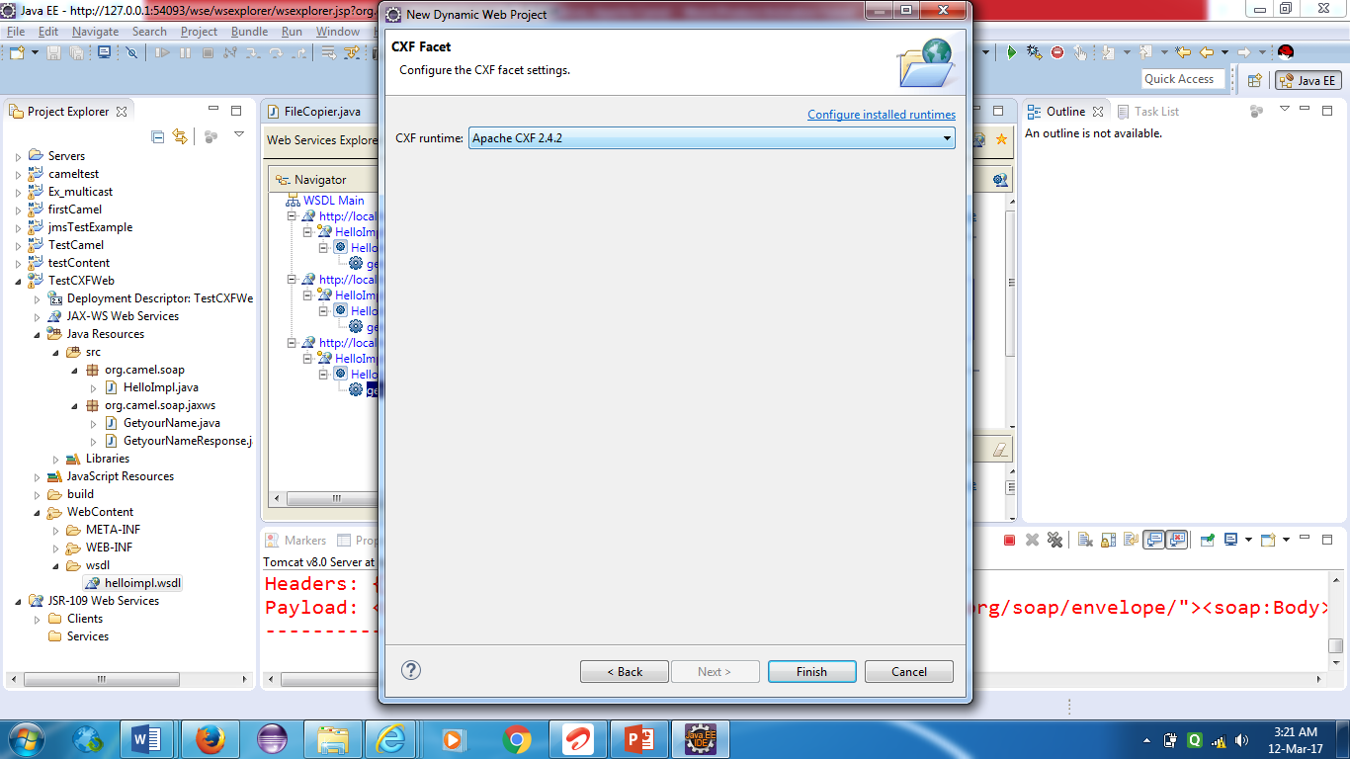

Step 8:

Java Resources🡪src🡪New Class

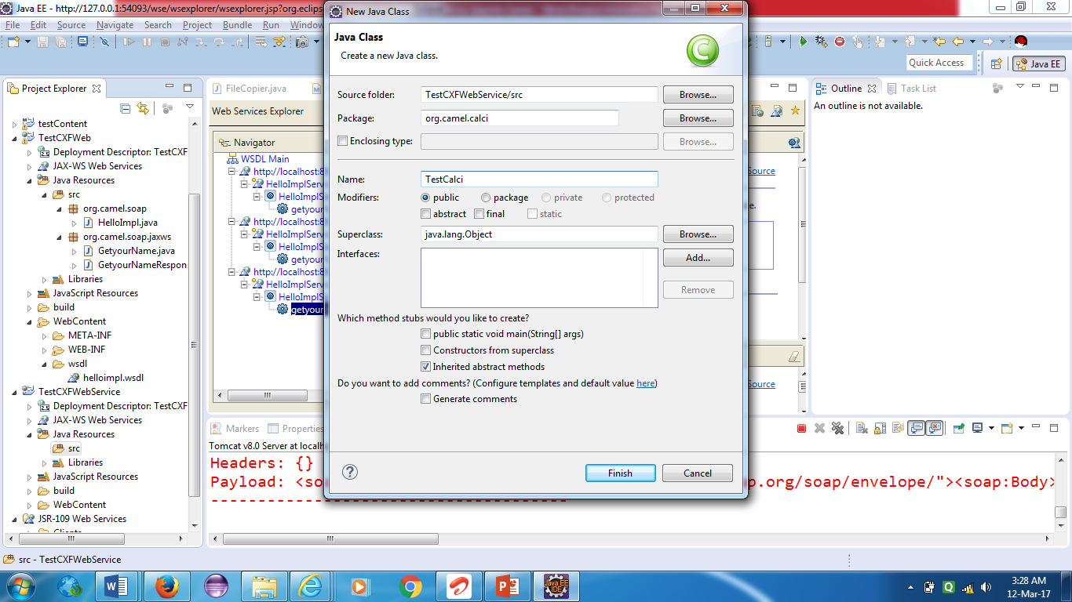

Step 9:

Write below code

**public** **class** TestCalci {

**public** **int** getAns(**int** x,**int** y){

**int** ans=x+y;

**return** ans;

}}

Step 10:

Right click on TestCalci and New🡪WebService

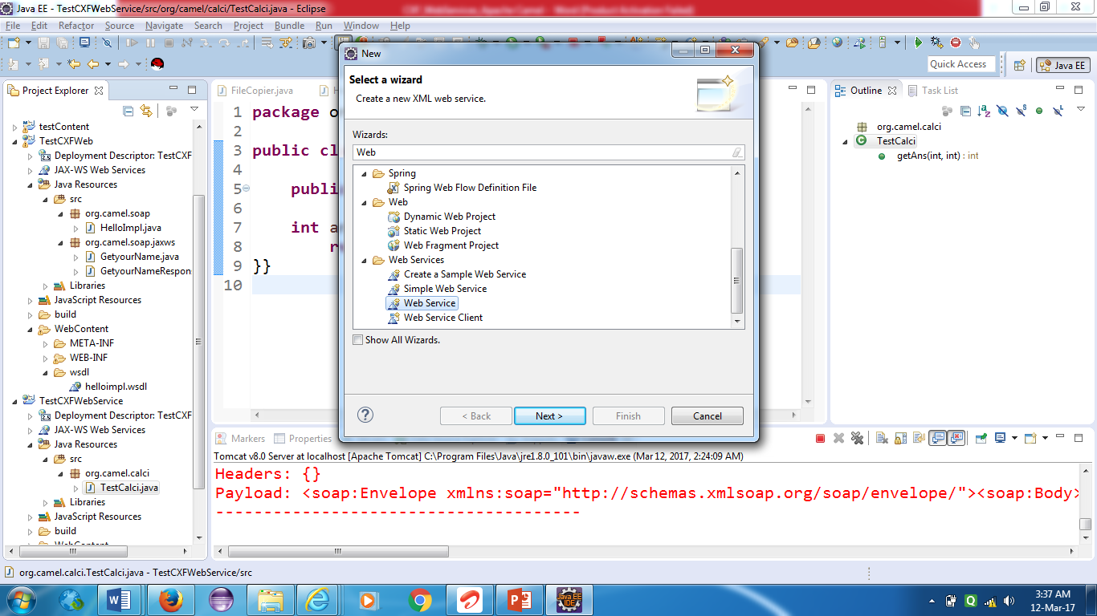

Step 11:Next

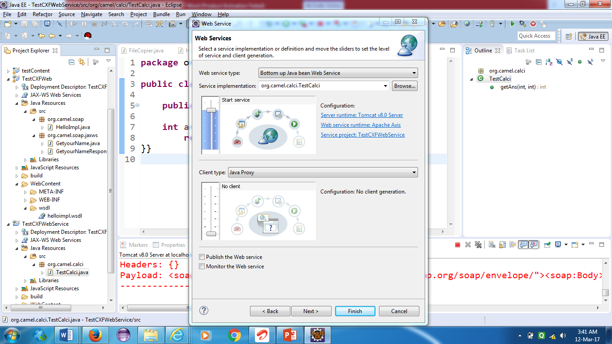

Step 12:click on web service runtime apache axis

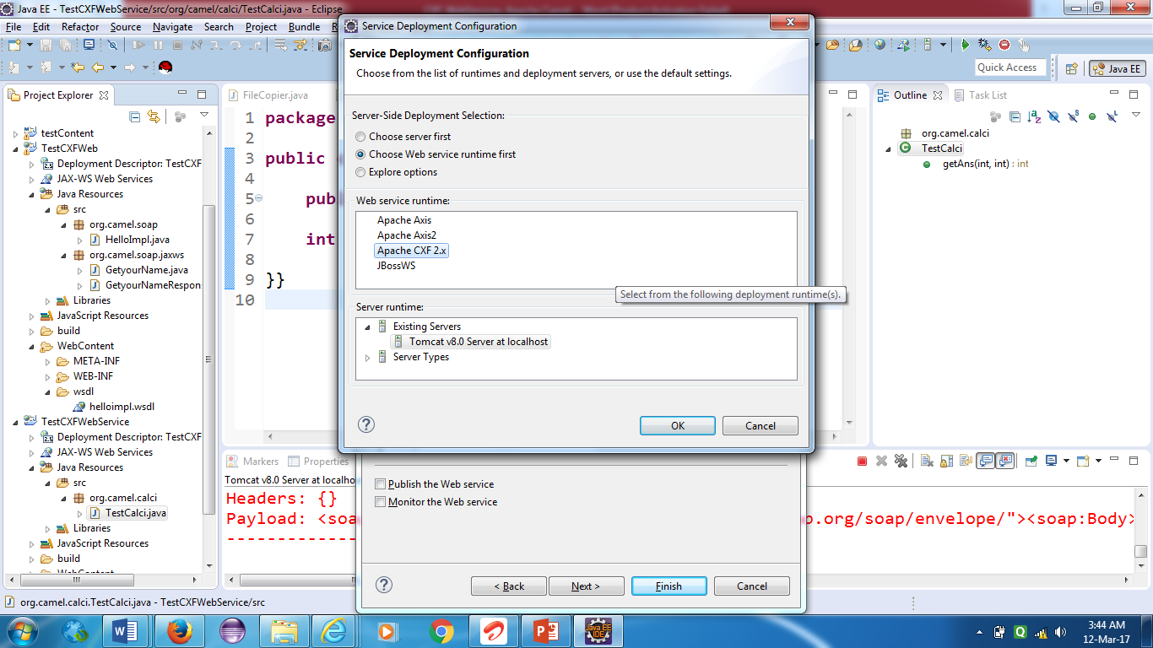

Click on Apache cxf 2.x.

Step 13:click next

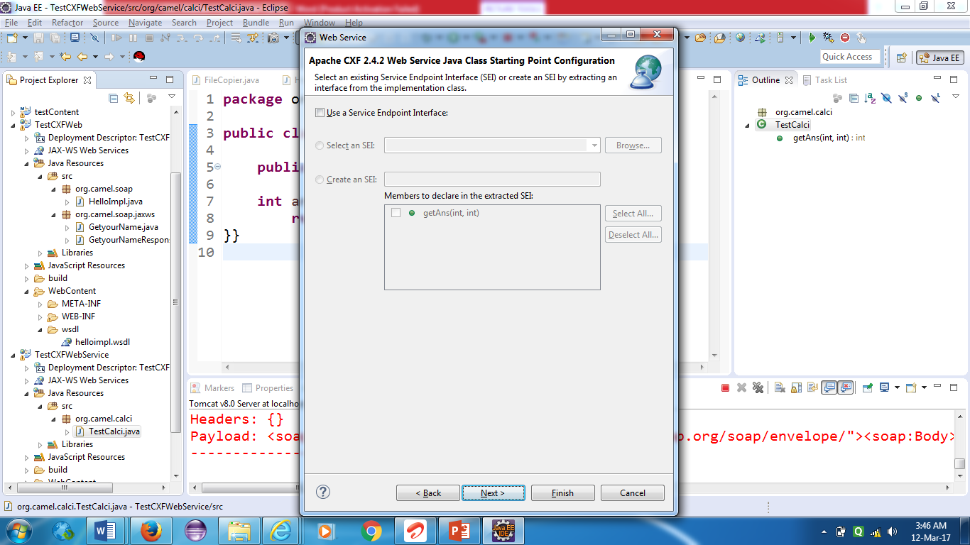

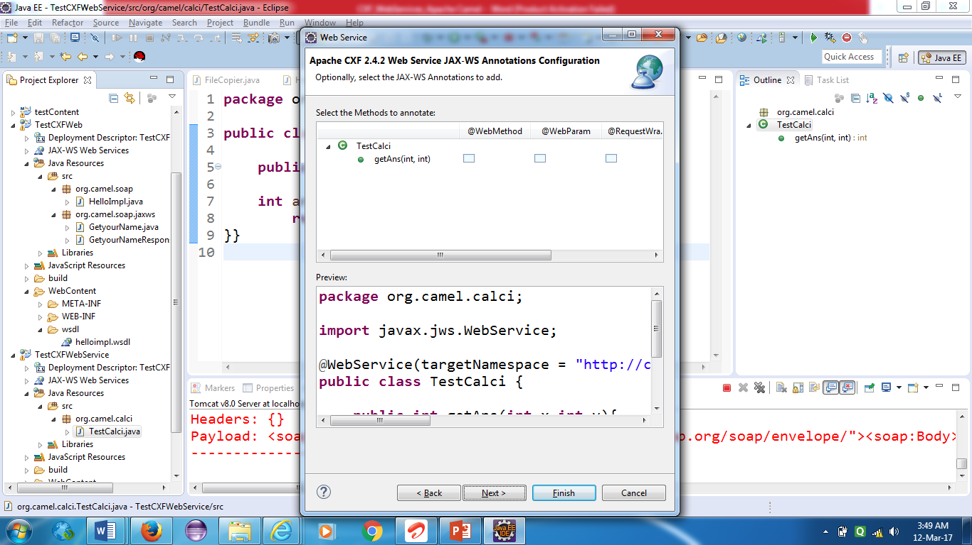

Step 14: Uncheck generate xsd

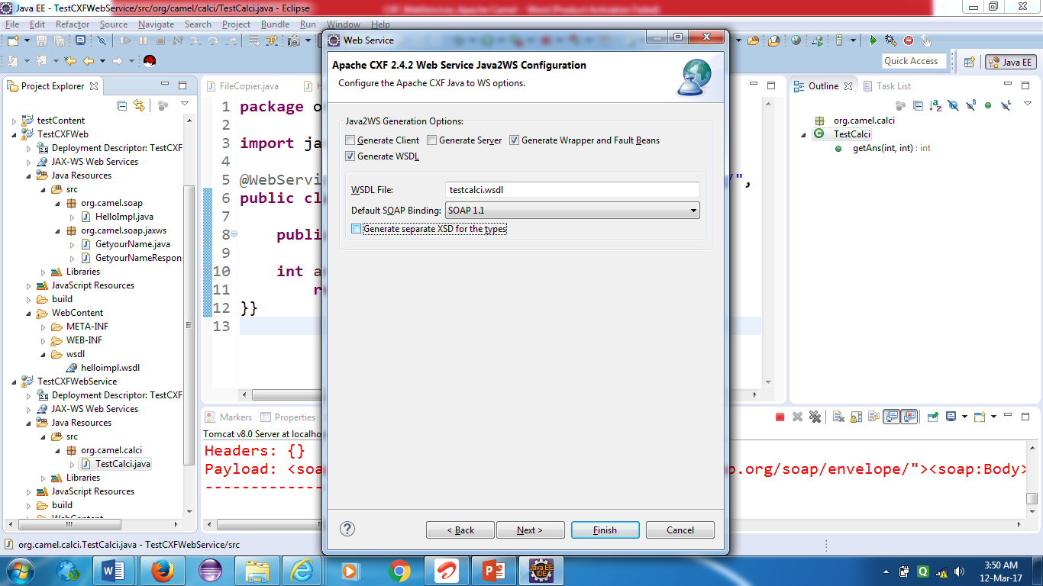

Click on next

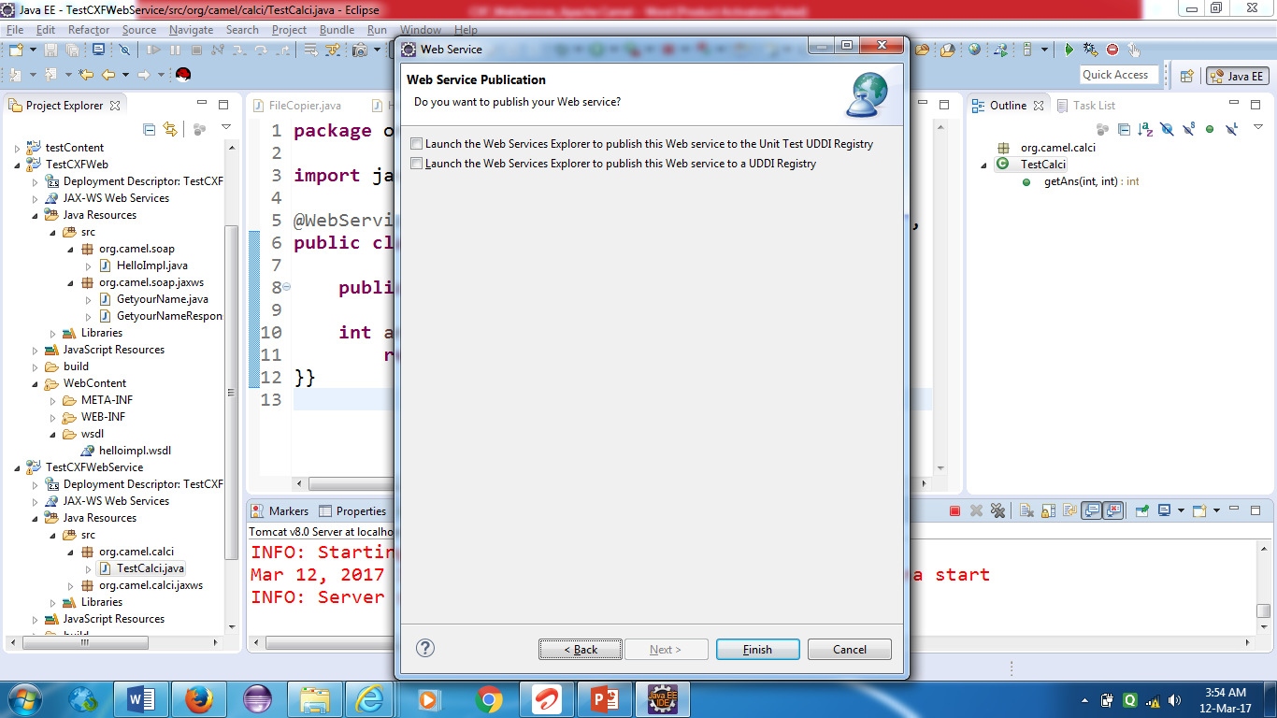

Click on finish.

Step 15:

Click on web content folder to see wsdl file

Click on wsdl which created

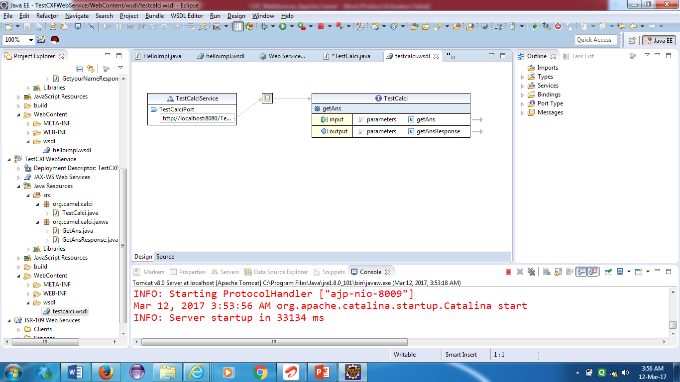

Step 16: Select URL from TestCalciService

<http://localhost:8080/TestCXFWebService/services/TestCalciPort?wsdl>

paste it in browser. If wsdl displayed then the web service is working properly.

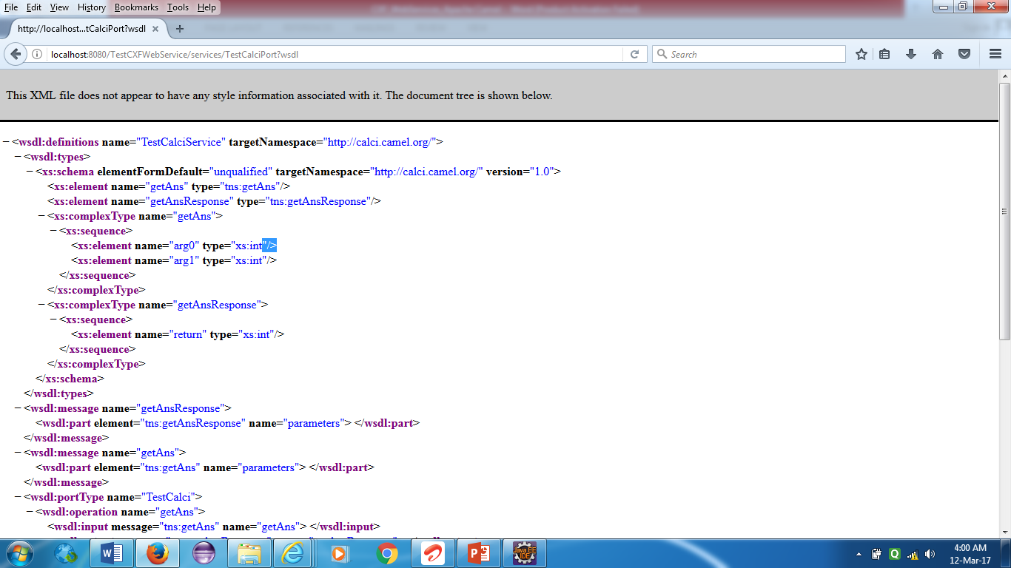

Step 17: Goto Run 🡪Launch Web Service Explorer

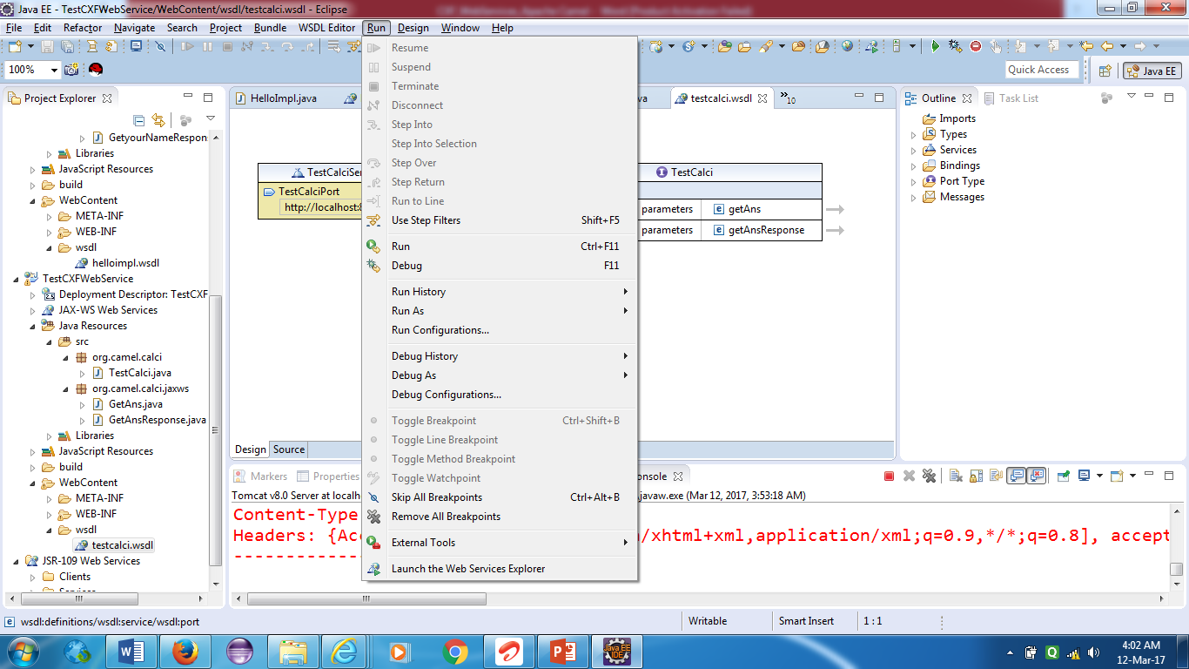

Step 18:

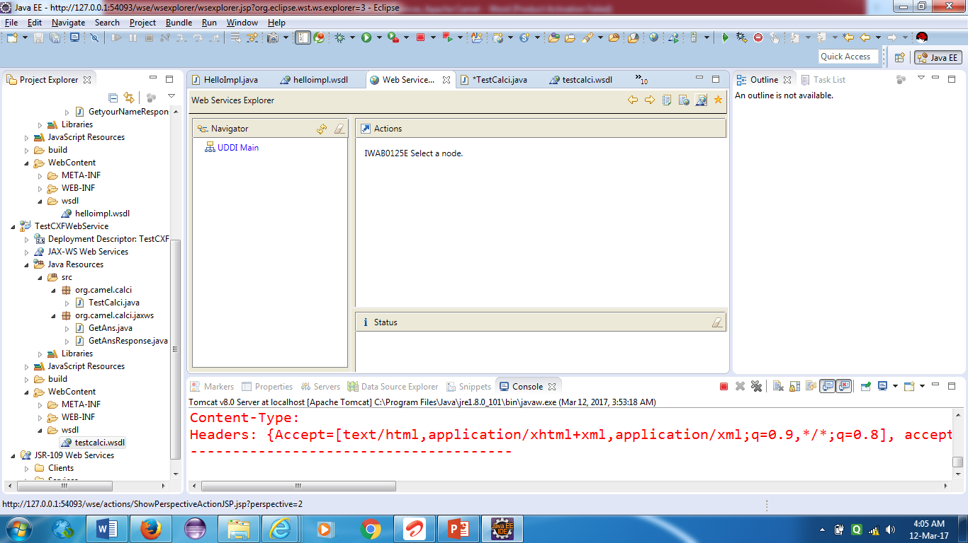

Click on wsdl page

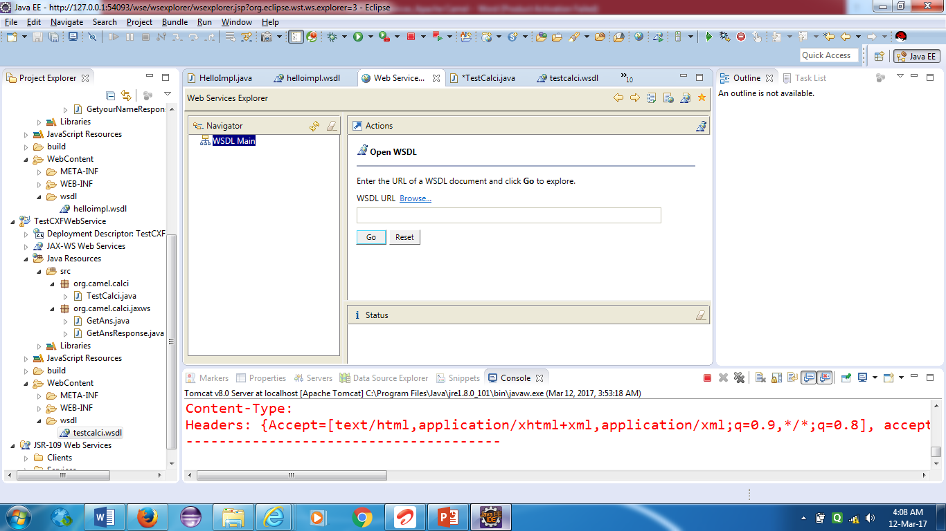

Type a url for wsdl file in box and click on go

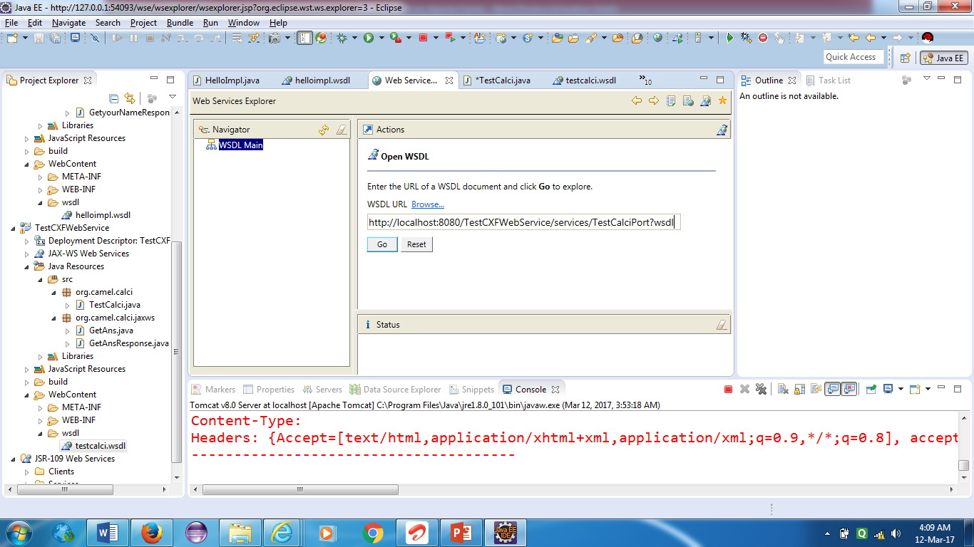

Click on getAns method

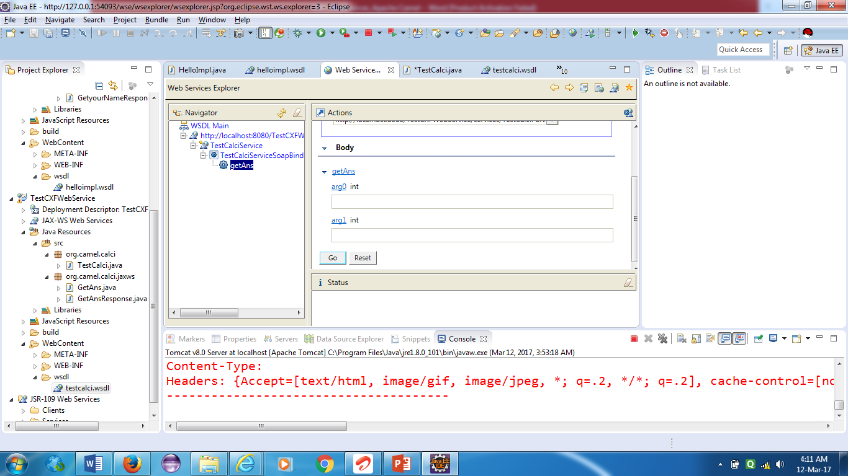

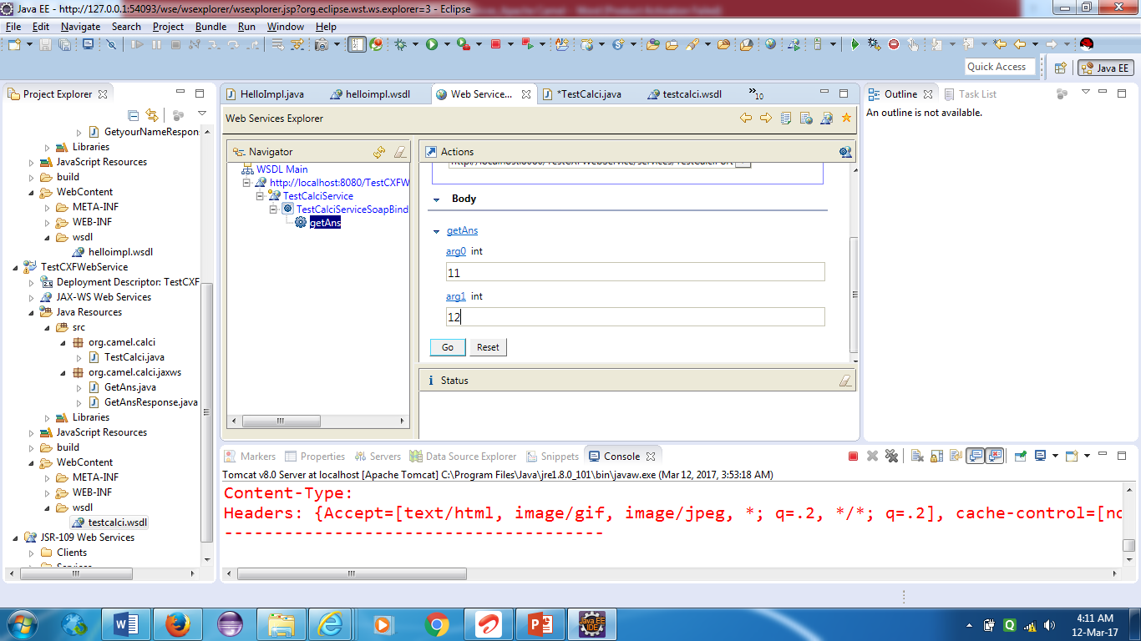

Enter two values for two argument which we have declared in getAns method.

Click on Go button.You can see the output as 23.

In status window.

